HGS  HARRISON GOVERNMENT SUPPLY LLC  MISSION READY. TRUSTED SUPPLY. EXCEPTIONAL SERVICE. |   Scan to visit  hgsfederal.com
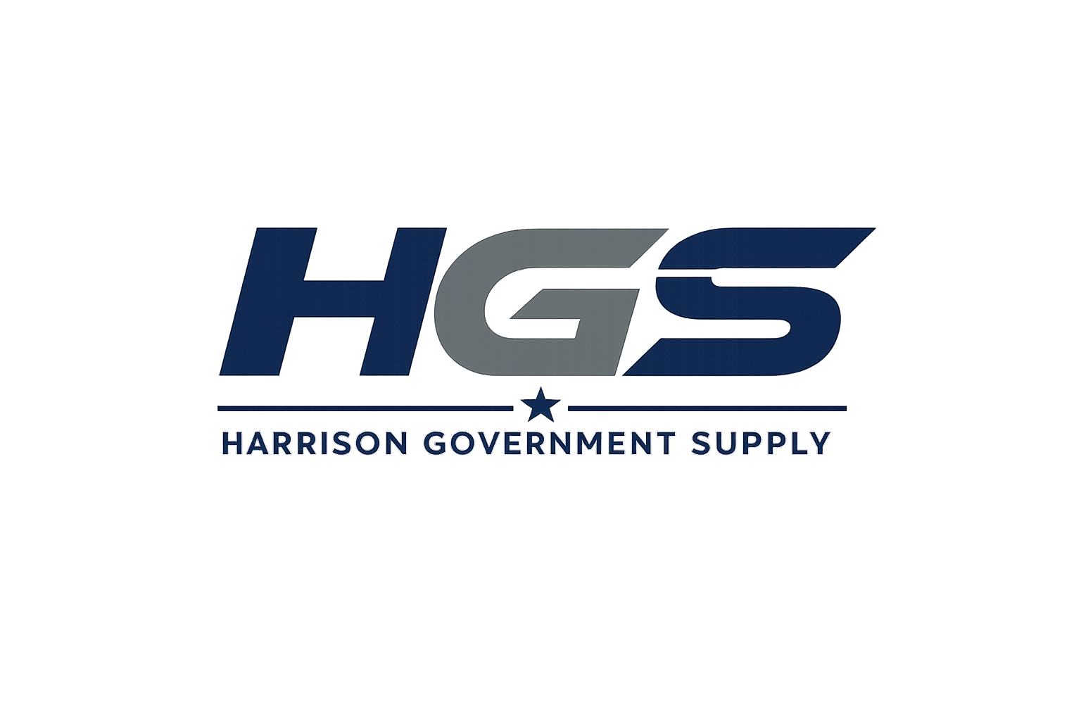

■ COMPANY OVERVIEW  Harrison Government Supply LLC (HGS) is a small-business procurement and distribution company providing reliable supply solutions to federal, state, and local agencies. HGS specializes in strategic sourcing, responsive customer service, and dependable delivery across a broad range of commercial products.  ■ CORE CAPABILITIES  - 🛠 MRO Supplies  - 🏥 Medical Supplies  - 💻 IT Products  - 🪑 Office Furniture & Supplies  - 🧹 Janitorial & Facility Supplies  - 🦺 Industrial & Safety  - 📦 Strategic Sourcing  - 🚚 Government Procurement Support  ■ DIFFERENTIATORS  ✔ Customer-first service  ✔ Rapid sourcing  ✔ Competitive pricing  ✔ Broad supplier network  ✔ Clear communication  ✔ On-time delivery | ■ COMPANY SNAPSHOT  UEI: XXFAE19KY833  CAGE: Pending  Business: Small Business LLC  Website: hgsfederal.com  Email: robert@hgsfederal.com  Address: 562 W McClellan St.  Ponchatoula, LA 70454  ■ PRIMARY NAICS  • 423990  • 423450  • 423420  • 423610  • 423840  • 423850  • 541614  ■ COMMITMENT  HGS is committed to providing dependable products, responsive communication, competitive pricing, and mission-focused support to government customers.

